 | Course Name: Design Patterns/Thinking LAB | EXPERIMENT NO. 1
 | Course Code: 20CP210P  Faculty: Dr. Ketan Sabale | Branch: CSE | Semester: IV
Submitted by: Manan Kapkar
Roll no: 23BCP336

Objective: To familiarize students with standard Creational design patterns.
Experiment: Explain the factory design pattern and write a program using any object-oriented programming language to demonstrate the working of factory design pattern.
Factory Design Pattern: The Factory Design Pattern is a creational design pattern that provides an interface for creating objects in a super class but allows subclasses to alter the type of objects that will be created. This pattern is often used to delegate the responsibility of object instantiation to a factory class, which determines the object type based on input parameters or logic.

Key Features:
- Encapsulation of Object Creation: The client code does not need to know the specific class being instantiated.
- Flexibility: It allows adding new types of objects without changing existing code.
- Loosely Coupled Code: The client depends on the factory interface rather than concrete classes.

Advantages of Factory Design Pattern
- Encapsulation of Object Creation Logic:
  - The client code does not need to know the details of how objects are created. This centralizes the creation logic within the factory class, reducing complexity in the client code.
- Loose Coupling:
  - The client code depends only on the abstract interface or factory, not on the concrete classes. This makes the system easier to extend and maintain.
- Flexibility in Adding New Types:
  - Adding new types of products (e.g., new shapes in the example above) is straightforward. You can add a new class and update the factory method without affecting the existing client code.

Disadvantages of Factory Design Pattern
- Complexity in Implementation:
  - Introducing a factory adds an additional layer of abstraction, which might make the code more complex for simple scenarios.
- Increased Code Overhead:
  - The factory pattern can introduce extra classes and methods, especially when the system has only a few object types.
- Hard to Extend in Large Systems:
  - If there are too many object types, the factory method can become too complex and difficult to manage.

Problem Statement:
Design a factory pattern that allows the user to choose from different companies of cars using a common factory which creates the car objects for different companies. The code should ask the brand from user and create the particular car object based on the user input. The solution should have modularity and scalability.
DIAGRAM:
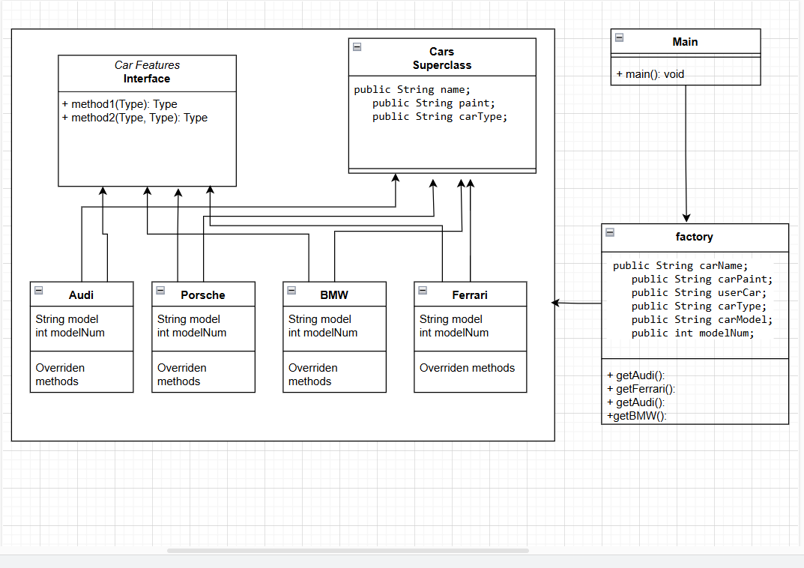

CODE:

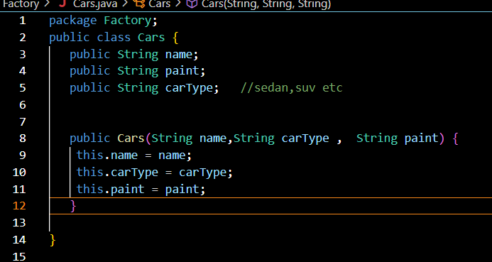
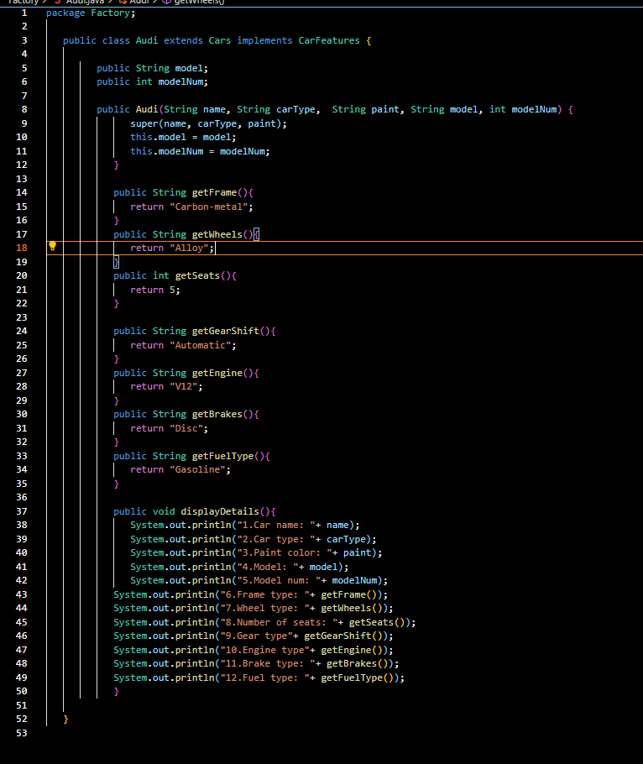
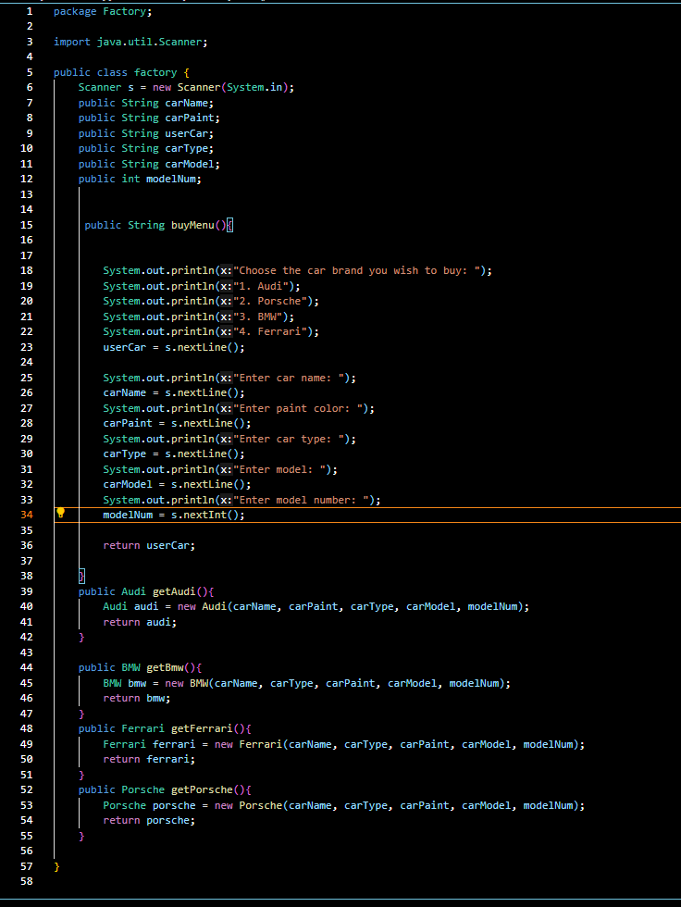
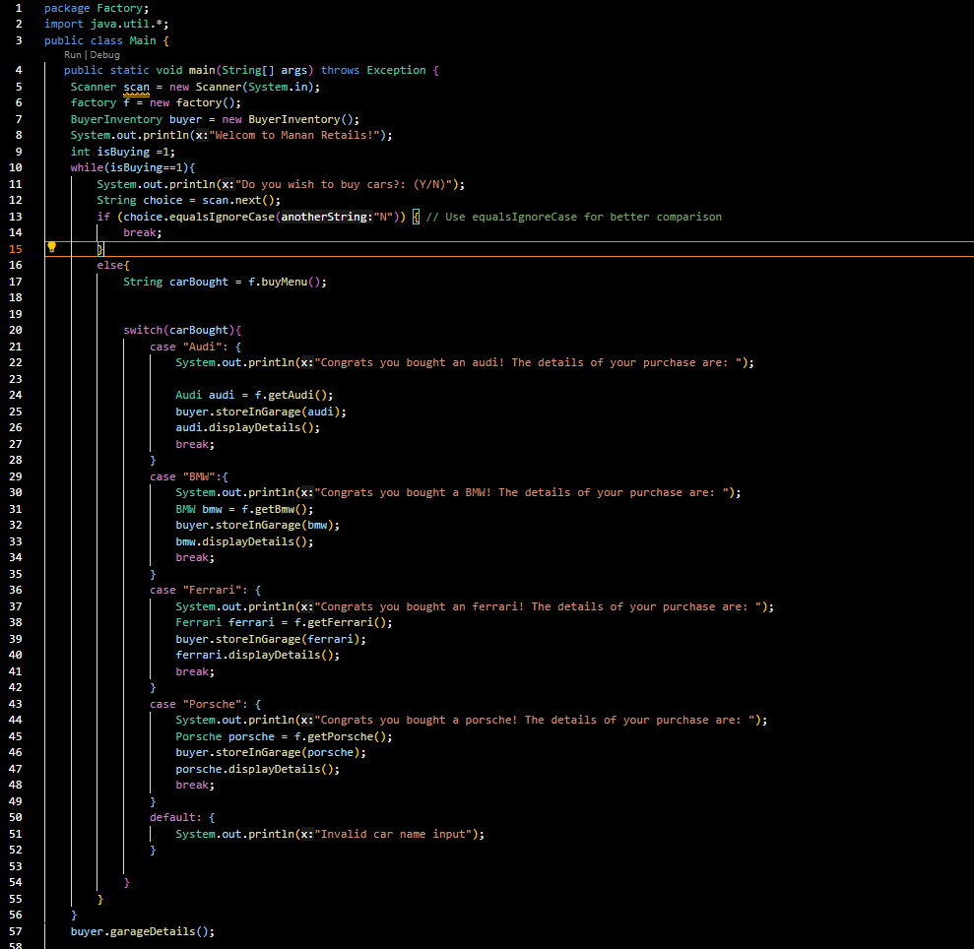

OUTPUT:
